SALORMEY VOLUNTEERS GROUP
ANNUAL REPORT
2015

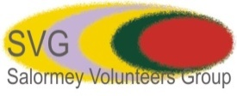

Table of contents

Foreword ………………………………………………………………………… 3-4

- Introduction…………………………………………………………………………….…5

- Towards achieving SVG objectives……………………………………....………. 8

  - Sustainable Development........…………...…………….…......…...... 8
  - Universal quality education......................................9 - 12
  - Health and well being.............................................13 - 14
  - Adequate Water and Sanitation..............................15 - 16
  - Gender equality
2. Local element: Community Awareness and Empowerment.........16-18

- Challenges ...........................................................................................19

- Plans for the future……………………………….……………....................…….19

- Conclusion and Main areas of learning .............................................. 20

- Appendix………………………………………………………………………………....21

FOREWORD

SVG has now ended its 2014/2015 working period. It has been a challenging time in terms primarily of funding; on the other hand it was also an exciting one in terms of new activities and partnerships undertaken, and one where despite challenges we managed to achieve most of the goals set out, as the report henceforth will showcase, and saw a strengthening of the organisation in the scope and reach of its work.

Last year’s report reflected on paper on the commencement of activities that facilitated achieving our goals of self development, inclusiveness and gender awareness. This annual report aims to illustrate the continuance of such aims in all our endeavours, but also reflect how our work has been leaning towards specialisation in certain areas such as the water and sanitation sector.

SVG’s work is still being developed in a context of a wide worldwide economic crisis; where charities have had to become creative in their approach and reach so as to still be able to develop both our inputs and outcomes; despite these external challenging and testing times, we have been able to confront it head on, as this report will attest, and have been able to achieve most of the goals we set out at the beginning on the period under study.

This has been possible thanks to the deeper level of inclusion of local and foreign stakeholders, improving the quality and quantity of their contributions and participation at various phases. It has enabled us to be more resilient while at the same time guaranteeing sustainability of projects on the ground.

Another distinctive feature of this period’s work is the introduction at an international level of -post MDGs- so called Sustainable Development Goals. The debates and conversations in this regard have allowed us to reflect upon our own goals and agenda for development. Our guiding principles are in accordance with current GOALS 3 – health and well being goals-; GOAL 4 –in regards to universal quality education-; GOAL 5 –gender equality-; and GOAL 6 –available, adequate water and sanitation-.

Per sector, we have expanded efforts in the areas of Education and Water and Sanitation. This has entailed refocusing and stressing on certain geographical areas, and has been accompanied by prior successes that have enabled and encouraged our partners to further support, as this report will showcase.
Positive results have confirmed to us and our partners that work done prior to this period has gone in the right direction and that efforts produce results desired as long as the commitment is maintained. Upon conducting monitoring exercises, we have realised the importance of continuous engagement with both partners and projects, which ultimately brings about adequate implementation and successful results.

Secondly, after realising the high demand for short term specialized interventions to address more pressing challenges, SVG has initiated activities that tackle this, above all in the health sector. This has been undertaken alongside SVG’s mainstream activities set out to achieve its medium and long term goals. This was done by learning from previously analysed successes and failures on similar areas of work, given by experienced in the field, and also by request from similar minded institutions and bodies instead of by a mere replication of comparable activities.

Again in 2015, we have continued to do all of the above in already existing but also new locations, which showcase our commitment to continuous growth of the geographical reach of our programs, regardless of any political, religious, ethnic or any other affiliation. This reflects the democratic spirit behind our foundation.

During this period, SVG has maintained its online presence, continuously updating its webpage and online tools, and in addition initiating use of other features such as blogs and new phone applications such as Instagram, Pinterest and others. Online networking allows us to overcome geographical hurdles while serving as a tool to promote and illustrate our operations. There is potential to improve our online engagement, however funding constrains does not allow us to explore this area as productively as we aspire to.

The outcomes of these inputs have resulted in the following: strengthening local partner institutions (improving the standards of the services they provide); empowering participants and other beneficiaries (building up knowledge networks and awareness); furthermore they put to test traditional ways of understanding individuals role as part of a developing society, and finally represent a learning mechanism for all those involved.
In addition, the project activities undertaken have addressed short term pressing needs arising in our communities that were previously not taken into consideration in similar areas of work.

This report assesses the successes, challenges and lessons learnt whilst projects are designed, implemented and delivered.

At SVG we will continue to work towards our goal of ‘improving existing services and initiating innovative ones, to meet those needs regarding community services (health and education) and community development’; this is a labour that SVG has been engaged on from its creation, and it is our conviction that by abiding by our beliefs, continued work, and support of all of those involved we will be able to reach these goals in the future.

The achievements that are shown in this report are attributable to all of those who make SVG; individuals and groups alike, local and foreign partner institutions and members of our staff who saw us through two successful years and to whom we owe our profoundest gratitude.

INTRODUCTION

SVG is a non for profit organisation operating in the Eastern Region of Ghana. It was founded by Ghanaians and it is being supported by Ghanaian and foreign philanthropists, individuals, volunteers, its staff and partner organisations since its inception in 2002.

SVG started its work with the aim of developing and implementing ethical volunteering practices in various development sectors in the communities where it works. Its ethos is those of Partnership, Solidarity and Respect.

SVG’s work is implemented by supporting local educational, health and other civil society institutions and stakeholders in various ways. Firstly, by placing volunteers in relevant areas, to strengthen the institutions via skill building; secondly, by engaging in projects that have mainly an educational aspect embedded in them; thirdly, by collaborating with local health authorities and institutions, providing them with material resources and hosting medical teams for unique assignments and others. All activities have a strong local component and aim at obtaining a medium term sustainable outcome.

The period 2014-2015 saw SVG engaging in new practices, strengthened its successes, created new partnerships and ultimately also faced challenges and setbacks. All of these are worth sharing with all our stakeholders and all other individuals and institutions interested in enhancing a vibrant civil society in Ghana.

This reports aims at documenting the work that SVG undertook in our OBJECTIVE AREAS

- SUSTAINABLE DEVELOPMENT

  - HEALTH AND WELL BEING
  - EDUCATION
  - GENDER EQUALITY
  - WATER AND SANITATION

- COMMUNITY AWARENESS AND EMPOWERMENT

- KNOWLEDGE NETWORKS
- SOCIAL INTERVENTIONS

- SUSTAINABLE DEVELOPMENT

To achieve this objective we focus on the following goals and processes:

- Tackling private and public health issues in linked sectors such as water and sanitation, and health delivery
- Tools to achieve increased levels of self development –efforts in the education sector
- Promote peaceful and inclusive societies for sustainable development Focus on education and community development; relevance of gender policies, making women central actors due to their productive and reproductive roles in our communities
- Innovative approaches to Education: a comprehensive and holistic approach that allows for improved quality and long term sustainable results

- COMMUNITY AWARENESS AND EMPOWERMENT

No development can take place unless communities are included at various levels of the design and implementation of projects, but also have the ability and are resilient enough to sustain project activities once donors depart. In addition to this, the adoption of new ways of doing things requires a certain level of behavioural change that is crucial to sustainable success.
Some of the activities on the ground that aim to achieve the above include supporting local skills development, awareness of the various gaps that hinder actions to reach the appropriate beneficiaries, social interventions ensuring inclusiveness, building up networks of trust and knowledge that circumvent traditional patterns of power distribution.

In addition to documenting and sharing SVG’s work in the areas enumerated above, the report seeks to capture some of the results obtained from the implementation of its projects, and finally to critically examine SVG’s finances.

- TOWARDS ACHIEVING SVG’s OBJECTIVES

CORE AIMS

  - Sustainable Development: working towards a sustainable future

  - Community Awareness and Development

Sustainable Development
seek feedback quotes from teachers/pupils

Oboyan D/A Primary & JHS Headteacher

As our annual 2013/14 annual report outlined, sustainability is at the core of our objectives. For us, Sustainable Development is ‘development now that bears in mind generations in the future; it means socio economic development done in a respectful way - towards the environment and including all members of society- and in doing so establishing strong basis for future generations’.

The post 2015 international development agenda focuses on the key concept of Sustainability; it has been the basis for most development actions internationally since the 90’s, and it has now been incorporated into the Sustainable Development Goals set out in 2015.

Reflection on the ground

When we approach a new activity or project the following questions inform our actions: is this something the community requests or is it externally ‘imposed’? Who will design the project? Who will manage the project once the implementation phase is concluded? And will the community be able to tackle repairs/upgrades/maintain outcomes without external support?

The answers on the ground should indicate that the communities:

  - Request an action
  - Contribute to the design and execution phases of project
  - Have the ability to manage and maintain activities geared towards success of action post completion

To achieve sustainability, SVG’s role is to undertake actions that ensure
  - Communities are included as key stakeholders in every phase of the project, thus are a part of its execution, are informed and knowledgeable about processes and their effects for the wider community, and finally can claim ownership and are accountable for its continuation.

  - SVG role in ensuring continuity by making material and human resources available, and by monitoring and evaluation ongoing processes and dynamics

Practical examples of this are the continued support to already ongoing projects, in a manner that respects the background where they take place but also lays out the conditions for introduction of new ways and approaches – skills training, new technologies training..... During the year under review there has been a focus firstly towards achieving and reinforcing the sustainability aspect in
projects initiated in previous periods and secondly in laying the foundation to improve on the quality of outcomes in activities undertaken in 2013-2014.

SVG’s has focused in this period in achieving the objectives laid out stressing the local components in a genuine way; from the ground up, inclusively, pragmatically and respecting the underlying principles of community. The tools of choice for this were multiple in nature and were developed simultaneously in time.

For this, SVG has continued to engage in activities that aim to achieve quality education by following a comprehensive approach; wide range participation in decision making on various stages of project development; promoting inclusiveness and achievable goals rather than externally imposed unrealistic objectives. This translated into the following: continuation of projects initiated in the least developed communities around the Lake Volta; expanding the reach of projects to other geographical areas such as the Kwahu East and West Districts; an aim at an inclusive approach that was not incorporated in previous years by addressing issues of education, health and well being in a all-inclusive manner; and finally by incorporation of new technologies to teaching materials and others.

The core aim of sustainability has also been incorporated into activities in the public health sector, again following aiming at outcomes following a multifaceted approach.

Education: a comprehensive approach

As done in previous years, we have encouraged school enrolment, participation and performance in various ways:

- Improving facilities, for instance renovating classrooms, repairing roofs, cementing classroom floors, indoors and outdoors painting upgrades– educational artwork and others- and other refurbishments. This has taken place in schools in the communities of Adawso, Nkyenenkyene, Obomeng, Mpraeso and Oboyan.
- New Upper Primary educational block facility at the Zongo area in Mpraeso
- New toilet blocks were built at the Presbyterian KG and Lower Primary school facilities in Obomeng.
- New water reservoir and pumping systems were set up for the Obo Community Library, and
- Toilet block at Adawso Sunrise School was completed after some setbacks due to water lake flooding in part of its structure.

Communities were involved actively in these activities, providing when realistic labour and materials such as sand –available locally-, water and stones; these activities aim to improve educational outputs in the long run but also address health issues within the school environment; this holistic approach has been incorporated into all of our interventions in educational facilities, and it aims to improve school performance and also to encourage school enrolment. It also aims at improving quality of service delivery.

The targeted communities or areas within communities were incorporated due to their vulnerability –less well off, more isolated or neglected from mainstream government action.

The looked-for effects of these projects are

- To encourage community engagement in the provision of basic services such as education
- an appreciation that these facilities nourish and aid to develop the community
- to increase the engagement of local government in these projects and
- the promote communities self awareness as to their right to demand these and similar facilities to encourage growth and tools for development
- to address vulnerability and other social needs

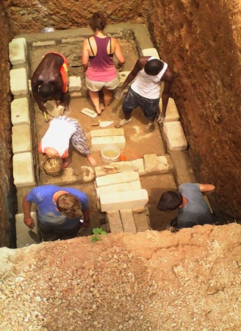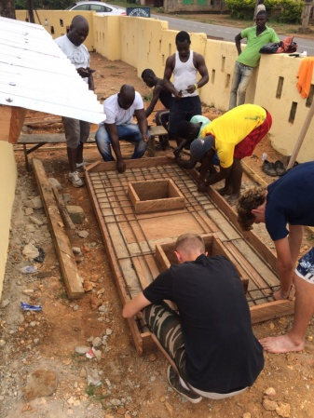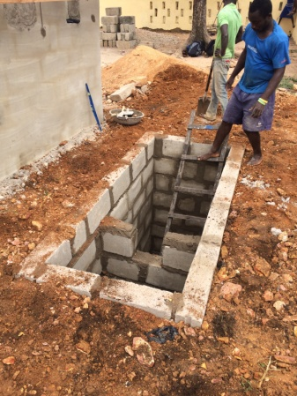
@svgafrica2015
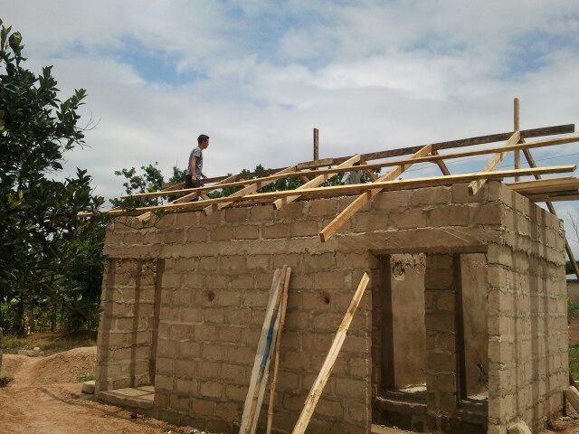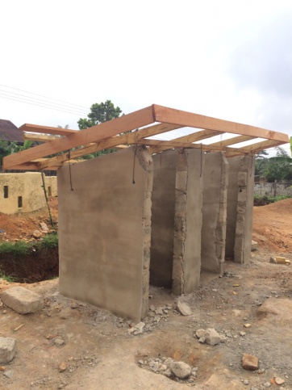
@svgafrica2015

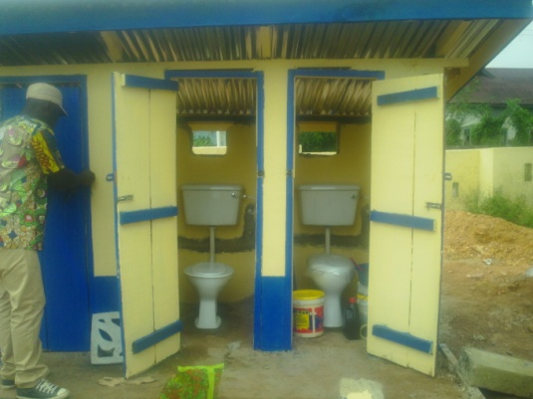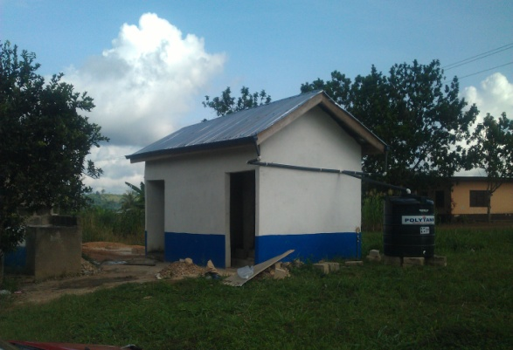
@svgafrica2015; building project pictures at Aduamoah, Adawso and Obomeng toilet blocks

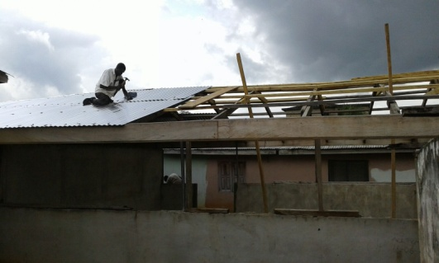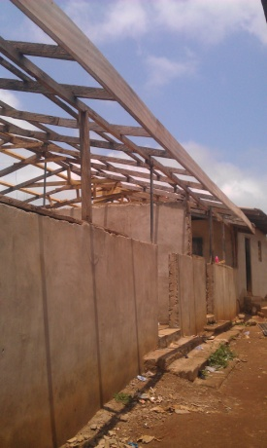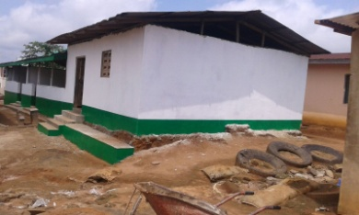
Zongo community Upper primary school building project

To achieve the objective of improving quality our intervention in the sector included as well as the above we employ tools such as classroom teaching assistance, donation of school supplies –books and educational materials such as stationery, activity books-; sports equipment –football kits, footballs, various sports kits and sets, training kits etc.; and furnishing classrooms and libraries with necessary educational resources.

Monitoring the success of education intervention that does not include visual outcomes such as structure building can only be done by assessing enrolment and performance numbers. This can be inaccurate since quantities vary due to various factors, and assessment should take account of this.

Nonetheless, it is possible to assess general improvements when taking part in teaching exercises, assessing literacy and cognitive skill improvement on a continuous evaluation basis.
Examples of the success of this approach can be seen in those institutions where our collaboration has been long term such as in schools in Bepong and Adawso. Reading and writing skills of children attending the premises have been encouraged and improved; comprehension and analytical skills are far above the average, and there is enthusiastic and positive feedback from students to our approach.

A holistic approach to education

Health and Well Being

Health Outreach Days consist in medical and nursing staff visiting ‘out-of-the-way’ communities to perform health interventions such as deworming, testing and treating for Schistosomiasis, infected wounds and bites and blood pressure screenings. The rationale for these visits comes from understanding that these communities:

- lacking basic services such as access to adequate sources of drinking water, thus vulnerable to the prevalence of water borne diseases
- usually located far from district hospitals, thus reliant on villages’ health centres covering wide populations with basic human and material resources
- reliant on health traditional practices and practitioners
- Might feel disengaged and on occasions mistrustful of modern medicine practices

MEDICAL OUTREACH PROGRAMS

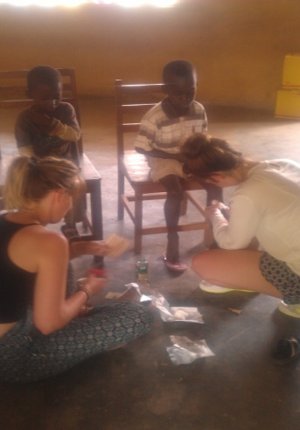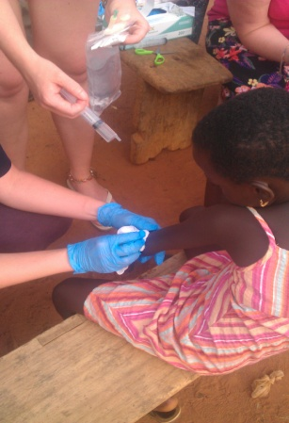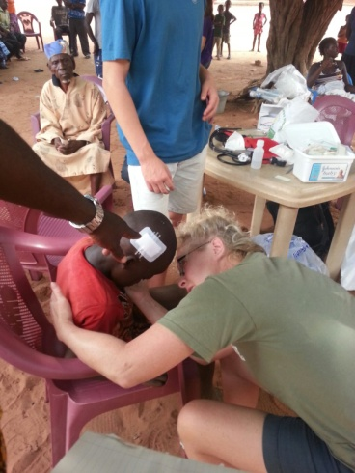

Adequate Water and Sanitation

Water is crucial for agriculture and other uses in Ghana; most farms producing cash crops such as cocoa and grains are not irrigated, and depend on rainfall in the rainy and lean seasons.

For the last couple of years in Ghana we have witnessed a shift in rain patterns; it brought about less rain than average; if predictions at global level of climate change are correct, these shifts will become the norm we will witness a regular decrease in rainfall averages in the near future.

Following this trend we feel it is more important than ever to increase focus in the Water and Sanitation field. Our new partnerships stress medium term solution measures, such as borehole drilling and water harvesting.

Gender policies

This is summarised conceptually in our goals in this regard:

To provide equitable access to resources and opportunities to men and women, both individually and in groups.
To take measures to ensure women and men's equitable access to and full participation in power structures and decision-making in our programmes.
To contribute to the goal of gender equality in staffing, particularly in higher management positions.
To include gender assessment as part of the analysis for each project

- COMMUNITY AWARENESS AND EMPOWERMENT

One of the main reasons for project failure and/or poor performance and outcomes is due to the fact that the approach and dynamics are externally imposed. From our experience with communities first hand, for a project to succeed, it must include the following features:
- it is both needed and demanded by the community
- It incorporates local stakeholders or people in positions of authority within the community and it is inclusive of all its users/beneficiaries
- It is designed to have provisions in place to withstand setbacks

Performance might in addition be affected negatively when actions carried out challenge customary behaviour and/or traditions, thus potentially meeting resistance within certain sectors of society. An example of this: sanitation projects challenging standard usage of water bodies for disposal of the products of human waste. In order to tackle the effects of these human activities it is thus vital to deal with the immediate cause –bacteria on the water, for instance by providing water filters- and most importantly with the primary cause – human behaviour.

Changing behaviour demands public interventions and we are part of this common effort of constant community outreach programs that tackle some of these issues. We have seen results among others in the education and water and sanitation areas; targeted communities have incorporated new patterns of behaviour for instance in water filters use and general health

- Building up resilience: by nourishing local skills/resources

Social and Economic Interventions

Other Private and Public Health interventions

- CHALLENGES

Here we distinguish internal and externally originated challenges.

Within the organisation, and from its inception, SVG has faced challenges pertaining its funding, due to its sole reliability on nongovernmental sources of financial support. Our willingness to exert independence from external organization policies and guidelines has made our expansion into new areas of work slower than it could have been.
This is something that might need to be reassessed in the light of positive outcomes of productive cooperation; SVG has already initiated changes in this respect by creating new alliances with similar organisations in our fields of work, especially like minded charities.

On the day to day development of operations, we have faced challenges at the implementation phase mainly. This might happen due to prior design phase errors unforeseen circumstances that do not allow for all objectives laid out being achieved, and budget shortages.
This can be dealt with by improving initial research and planning phase, clear identification of objectives and understanding of such objectives by all parties involved and/or affected by project development and by accepting overall decision capacity by those that are affected by projects. Improved fundraising, budget management and marketing techniques are amongst our objectives for the year 2016.

Again, one of our main challenges has been the external financial climate, which on occasion demands downsizing and budget revisiting and redesign. Our way to build resilience has consisted in the expansion of our partnerships as we have done in the past, downsizing when needed and seasonally rather than permanently employing personnel, and similar measures.

- PLANS FOR THE FUTURE

We believe SVG has by now established itself as one of the key civil society stakeholders in the Kwahu Districts and specifically the Eastern Region of Ghana in the six years. Current plans for the years 2016/17 aim at maintaining project load and on improving quality of service delivered.

This would be achieved by:

- Strengthening ties and engagement with District Assemblies relevant departments
- Ensuring successful –i.e. sustainable- projects initiated in past and present periods under study
- Increased participation and inclusiveness of targeted population groups, from the inception of the projects to their monitoring and evaluation phases
- Increased efficiency; improving outcomes cutting down unnecessary costs and streamlining objectives and streamlining courses of action
- Further partnerships in relevant areas

- CONCLUSION and MAIN AREAS OF LEARNING

During the period under review, some of the approaches and conceptual work we involved in changed, that is, we attempted to take a fresh outlook at solutions to long-lasting challenges.
This has allowed in our opinion a deeper understanding of the activities undertaken, and therefore an opportunity to affect changes in a more meaningful way than on previous work. It has also presented some risks and added complications, mainly logistical. As usual, our aim is to take into account and learn from what works but also from what doesn’t, in order to set the objectives that will inform the next period of work.

In measuring the ‘results’ especially in the education sector; the outcomes and impact are not immediately obvious or quantifiable. There are other areas where measurable outcomes are more obvious, such as interventions in the health sector –number of patients seen/operated on; number of water filters distributed, population benefiting from a water borehole and others. These baseline measurements will serve from now on as a comparable dimension.
In view of this, it is important to set realistic targets and timelines within which Project goals and objectives can be achieved. Changes or impact on the lives of a target group can take time to register and even when it does happen, attributing the change to a specific intervention can be problematic. Thus, all potential effects including less positive ones should be considered especially when designing a project and adequate measures must be put in place to avoid these.

Another area of work where SVG needs to buttress is ensuring full participation of communities in project development and monitoring; a lack of a fluid communication and engagement of all stakeholders might result in wrong assumptions, frustration on the part of the implementing groups, project aims not fully achieved etc.; thus beneficiaries might feel excluded on decision making processes which in turn affect the sustainability of projects. We must be especially cautious that prior harmful dynamics are not reverted to upon project completion.

SVG aims at continuing with its work in the education area, which has produced in some cases very satisfactory outcomes; part of the effort in this area will include the establishment of links between foreign and local schools for the provision of adequate teacher training/exposure, and funding. We are very excited with the new partnerships we established in 2015 and aim in the next biannual period to strengthen these and initiate others.

Finally, SVG will need to engage more deeply with both domestic and foreign partners in order to allow it to overcome current challenges at various levels and expand operations in the near future.

- Appendix

6.1.Contact details

SVG secretariat

Frederick Frempong
Atibie Quarters, Atibie
info@svgafrica.org
PO BOX 256 Mpraeso-Kwahu
T: +233 244177488/ 246822273

6.2. Partners

Original Volunteers, UK, Education Projects
Anidaso Health, US Charity, Health Projects
Children of Abraham, US Charity, Health Projects
Griffaid, UK Charity, Water and Sanitation Projects
The Helen Hodgkins Trust, UK Charity, Water and Sanitation Projects

