SALORMEY VOLUNTEERS GROUP
ANNUAL REPORT
2011-2012

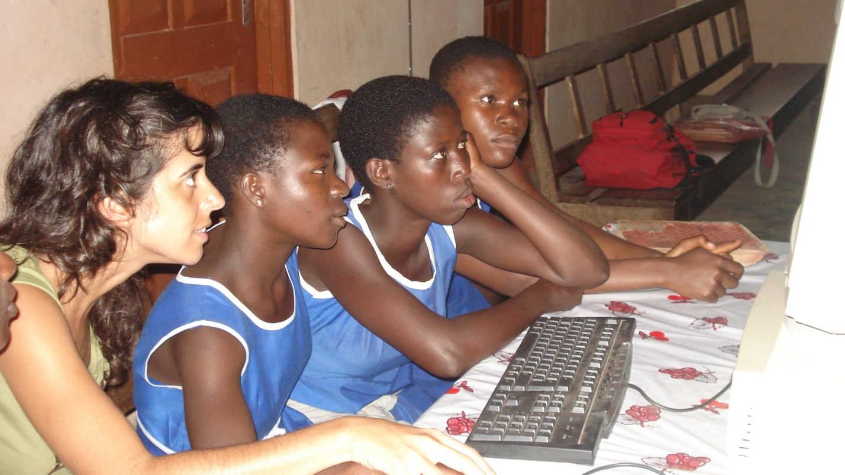

Table of contents

Foreword …………………………………………………………………………………..3

- Introduction…………………………………………………………………………….…4

- Towards achieving SVG objectives……………………………………....………. 5
  - Sustainability.................................…………...…………….…......…. 5
  - Gender Policies……………………………………………………………………………..9

  - Short Term Volunteering for Long Term Development……….. 10
  - Codes of Good Practice ………………………………………………..……..10

- Main areas of learning……………………………………………….…………………11

- Appendix……………………………………………………………………………….......12

FOREWORD

SVG completed its work for the biannual period 2011-2012. During this time, SVG developed sustainable activities in the areas of focus –education, health and community development, reinforced partnerships already established, improved methods of delivery, implemented both staff and members ethical codes of conduct and supervised and modified when necessary current administration structures.

During this period, SVG supported and strengthened its partner local institutions by provision of training and material resources needed to achieve their goals, but also engaged in the refurbishment and construction of adequate facilities for some of these institutions; this further explored SVG’s entire core aims i.e. the provision of tools to achieve self sufficiency and self development. SVG expanded its geographical reach; this was done by learning from previously analysed successes and failures on similar areas of work, instead of by a mere replication of comparable activities.

The outcome of these inputs have been not only the strengthening of local partner institutions, improving the standards of the services they provide, and the empowerment of those being an element of the partnerships; but also a challenge to traditional ways of understanding individuals role as part of a developing society, and finally as a learning mechanism for all those involved. We are confident that those who took part in these projects and activities, those benefiting from them and those implementing them, built up knowledge and an awareness that was previously not taken into consideration in similar areas of work.

This report assesses the successes, challenges and lessons learnt whilst projects where being designed, implemented and delivered.

At SVG we will continue to work towards our goal of ‘improving existing services and initiating innovative ones, to meet those needs regarding community services (health and education) and community development’; this is a labour that SVG has been engaged on from its creation, and it is our conviction that by abiding by our beliefs, continued work, and support of all of those involved we will be able to reach these goals in the future.

The achievements that are shown in this report are attributable to all of those who make SVG; individuals and groups alike, local and foreign partner institutions and members of our staff who saw us through two successful years and to whom we owe our profoundest gratitude.

INTRODUCTION

SVG is a non for profit organisation initially founded by Ghanaians and supported by Ghanaian and foreign philanthropists, individuals and organisations, which geographically bases its work in communities of the Kwahu Districts in the Eastern Region of Ghana.

A key objective of SVG is to initiate and support good volunteering practices in development in the communities where it works. Its main concepts are those of Partnership, Solidarity and Respect.

This is done by SVG through the encouragement and support of local educational institutions, either via placement of volunteers to strength skill building, or by engaging in projects that have mainly an educational aspect embedded in them. All activities have a strong local component and aim at obtaining a medium term sustainable outcome.

During the period 2011-2012, SVG has boasted successes, but also faced challenges, both of which are worth sharing with all our stakeholders and all other individuals and institutions interested in enhancing a vibrant civil society in Ghana.

This reports aims at documenting the work that SVG undertook in our OBJECTIVE AREAS

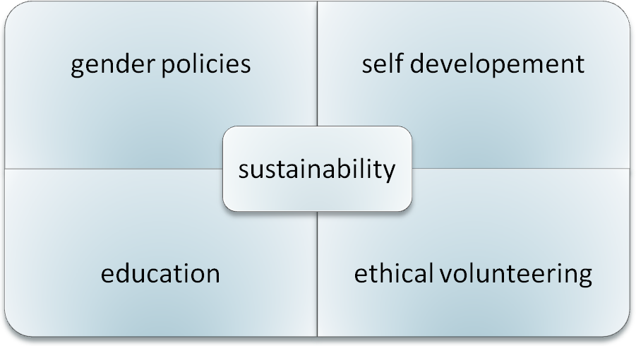

- Sustainability as the way towards successful development
- Focus on education and community development; relevance of gender policies
- Education: Short Term Volunteering for Long Term Development
- Codes of good practice

In addition to documenting and sharing SVG’s work in the areas enumerated above, the report seeks to capture some of the results obtained from the implementation of its projects, and finally to critically examine SVG’s finances.

- TOWARDS ACHIEVING SVG’s OBJECTIVES
‘....the support given by large groups of volunteers who give up their time and comforts to help others to thrive is a memory we will cherish for years to come...’
Asubone/Mangoase Teaching Staff, Asubone Primary-JHS
  - CORE AIM: sustainability

Sustainable Development as defined by UN and other international agencies is development now that bears in mind the future; it is working today in a respectful way: towards the environment, towards social and economic objectives, and in doing so establishing strong basis for future generations to come. The foundations of such Ghana are built today, and our projects have incorporated visions of future development as a core part of their design and implementation.

During the years under review, there was a focus towards achieving sustainability both in projects completed in previous periods and in those initiated in 2011-2012. SVG has aimed at developing activities that are of use today and that build on for tomorrow, and thus educational work of the highest standard has been the tool of choice to achieve such desired outcomes. The ideas that sustain this work have been reflected in the continuation and expansion of the support in the education area, to continue assisting those projects in least developed communities around the Lake Volta; these communities continue to suffer from their undervalued livelihood activities, and tend to be the ones to suffer most from external shocks. SVG has expanded these partnerships to other communities in similar circumstances as those described above.

Education

The villages of Osubensu, Asubone/Mangoase, Adawso and Nkyenenkyene saw their communities involved in the upgrading and rebuilding of school structures, -non-existent in the case of Osubensu and Asubone/Mangoase, for instance – and the creation of computer labs –Nkyenenkyene and Adawso-; the communities assisted providing labour and land ; this has resulted in the provision of a safe environment, enhanced means of delivery of their services, and an encouragement has been given towards the use of these facilities –with the output of higher school enrolment, improved grades for its students, and also added material resources to the centres.

A desired effect of these projects will be the encouragement of communities towards engagement in the provision of basic services such as education, and understanding that educational facilities are fertilizers for their communities; an added aspect or challenge is the engagement of local government in the projects and the realization of these communities as to their rights in the demand for these and other community facilities.

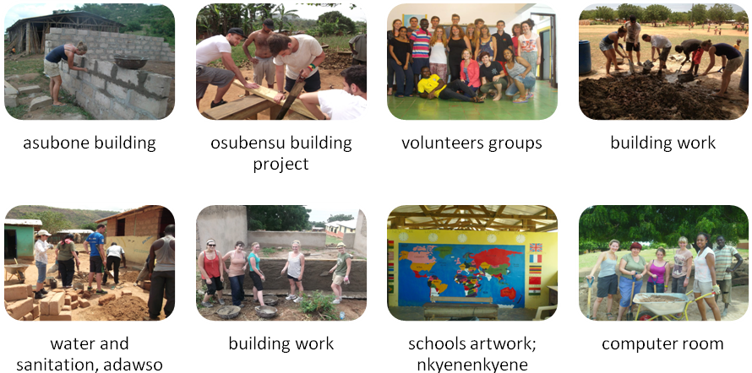

Obo
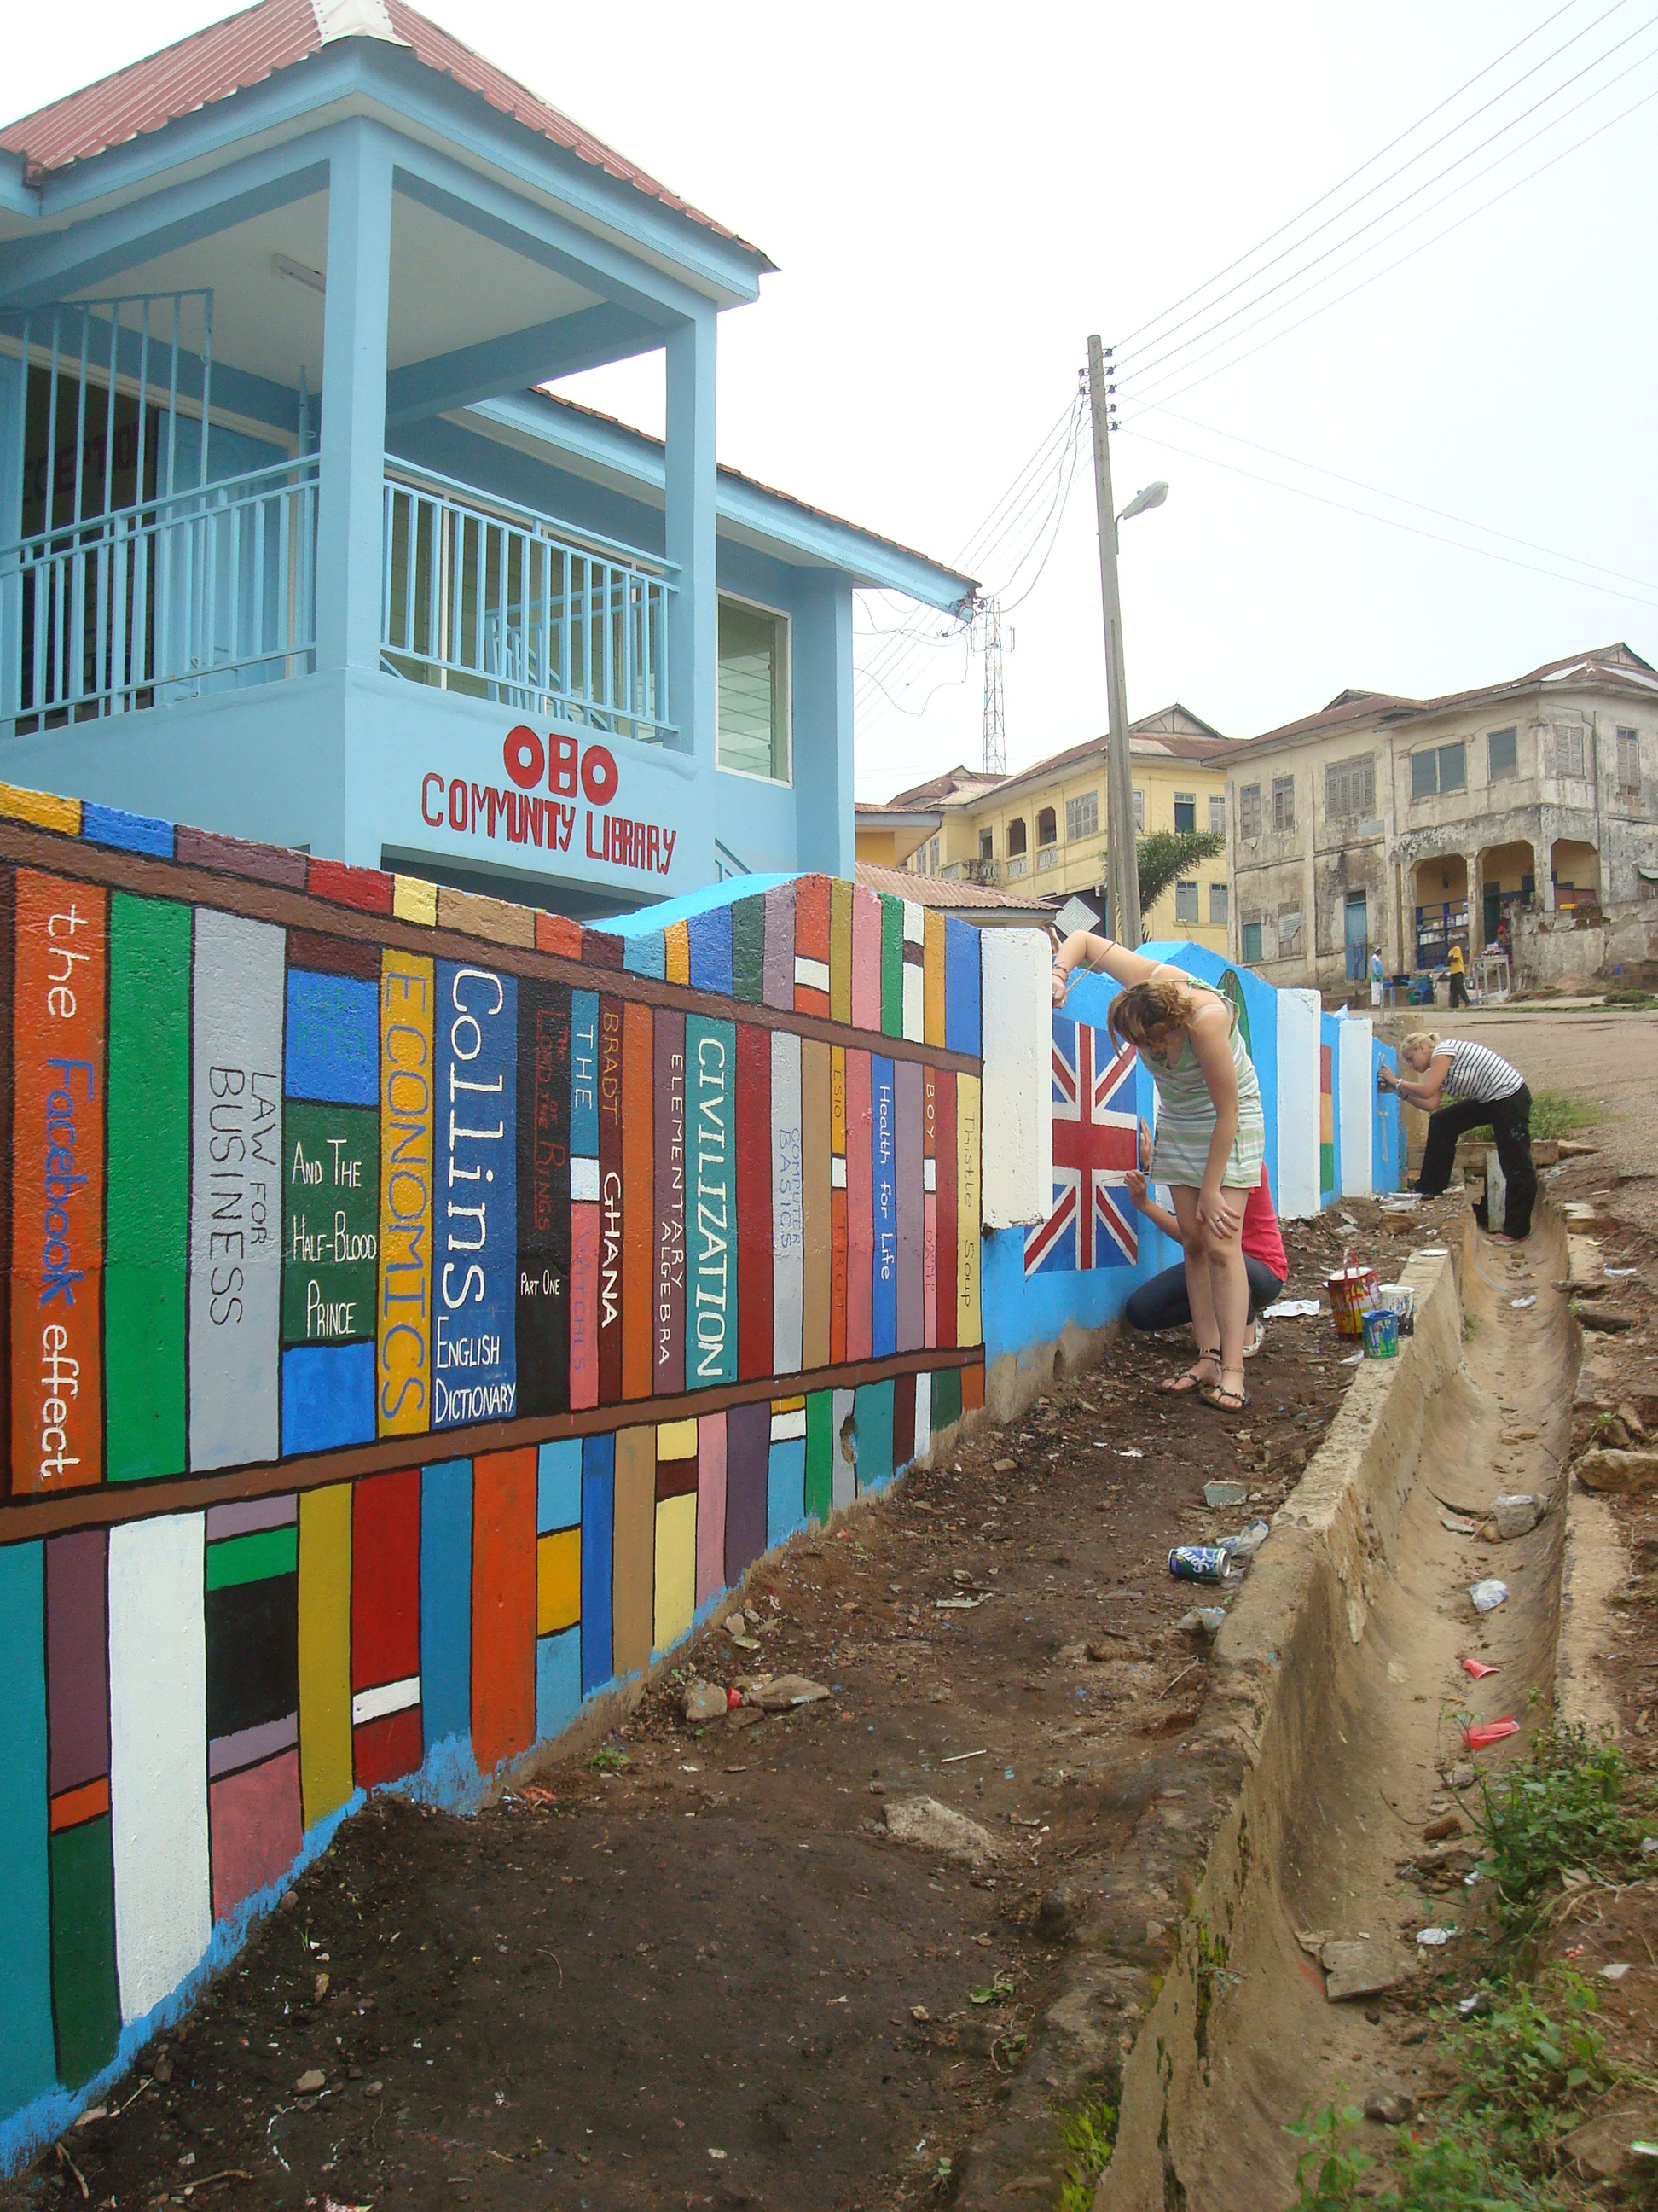

Expanding the work done at the Obomeng Community Library in previous years, a Community Library was set up at Obo township; this involved construction work, setting up of water harvesting tank, new toilets, and finally the setting up of various spaces for a range of age groups.
Donation of library materials and educational resources and finally five computers saw the completion of the initial phase of the projects, which has now embarked on the job of serving as a key part of the cultural and recreational activities for the youth and adults in the target community.

Community

Library

Water and sanitation
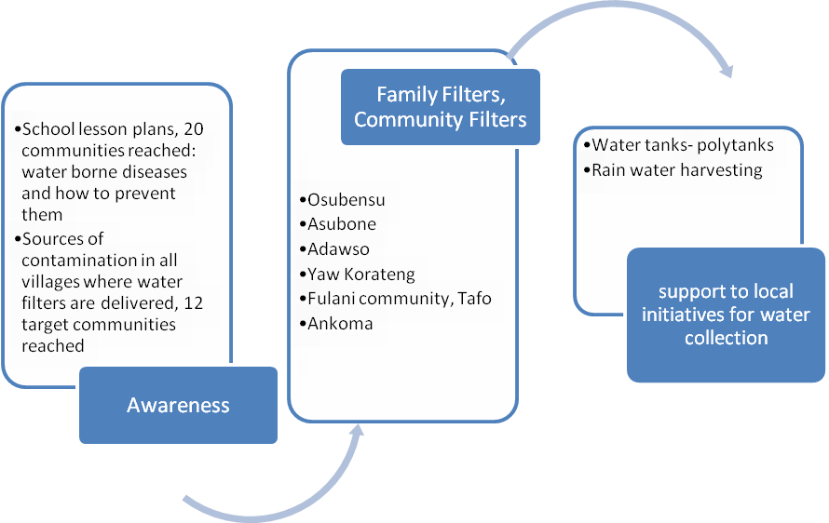

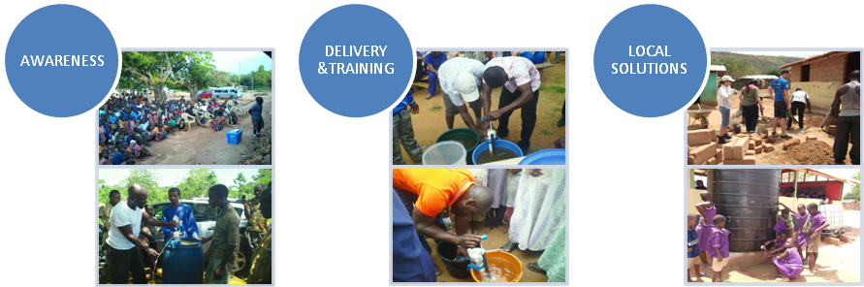

Health

Health Outreach programmes took place in various district communities; these are lacking basic services such as access to adequate sources of drinking water and are thus more vulnerable to the prevalence of water borne diseases; they are usually located far from district hospitals and are reliant on health centres that cover wide areas of land with the most basic human and material resources. A key aim was to support the difficult task of the public health institutions that operate in these districts.

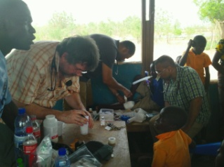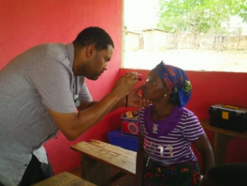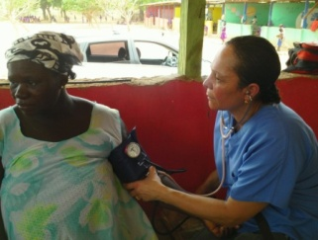

  - Gender policies

This is summarised conceptually in our goals in this regard:

To provide equitable access to resources and opportunities to men and women , both individually and in groups.
To take measures to ensure women and men's equitable access to and full participation in power structures and decision-making in our programmes.
To contribute to the goal of gender equality in staffing, particularly in higher management positions.
To include gender assessment as part of the analysis for each project.

  - Education: Short Term Volunteering for Long Term Development

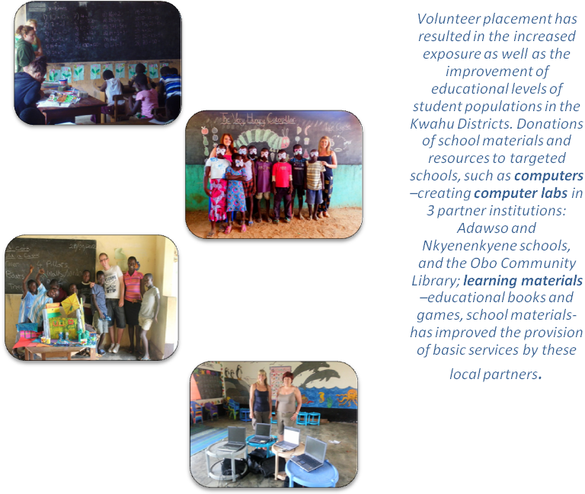

  - Codes of Good Practice

SVG aims and works towards setting standards for short-term volunteering in the developing world, for the use of hosting organisations and volunteers. This is achieved by providing and stressing on strict guidelines and induction/training of individuals engaging in these kind of projects –volunteer charters, orientation sessions- but also by ensuring an increased flow of information between hosting organisations and their source channels.
All of this aims to a responsible volunteering, Through this, we aspire at making host communities aware also of their rights, becoming more involved in programme design and implementation, being in turn more responsive to the communities they serve. Finally, it ensures the provision of good quality volunteering programmes.
SVG’s Volunteer Code principles adhered to those described on Volunteer Charters by Comhl’amh, an Irish based organization focusing on providing orientation for volunteers overseas, and which focuses on the increased need for accountability to the agency or community in which the volunteering is based.
- MAIN AREAS OF LEARNING

During the period under review, many of the groups we worked with reported results and feedback, which should help and inform in the future direction of our efforts in the programs undertaken.

In measuring the ‘results’ of some of the engagement especially in the education sector; the outcomes and impact are not immediately obvious or achievable. In view of this, it is important to set realistic targets and timelines within which Project goals and objectives can be achieved. Changes or impact on the lives of a target group can take time to register and even when it does happen, attributing the change to a specific intervention can be problematic.

Another area of work where SVG needs to be engaged in is the full participation of communities in project development and monitoring; a lack of a fluid communication and engagement of all stakeholders might result in wrong assumptions, frustration on the part of the implementing groups, project aims not fully achieved etc.; thus beneficiaries might feel excluded on decision making processes which in turn affect the sustainability of projects.

SVG aims at continuing with its work in the education area, which has produced in some cases very satisfactory outcomes; part of the effort in this area will include the establishment of links between foreign and local schools for the provision of adequate teacher training/exposure, and funding

- Appendix

4.1.Contact details

SVG secretariat

Frederick Frempong
info@svgafrica.org
PO BOX 256 Mpraeso-Kwahu
T: +233 244177488/ 246822273

4.2. Partners

Original Volunteers, UK, Education Projects
Anidaso Health, US Charity, Health Projects
Children of Abraham, US Charity, Health Projects
Save the Mothers Trust, UK Charity, Education/Building Projects
Aqualfilter Trust, UK Charity, Water and Sanitation Projects

